Kathleen Burns
November 19, 1954 – June 19, 2016

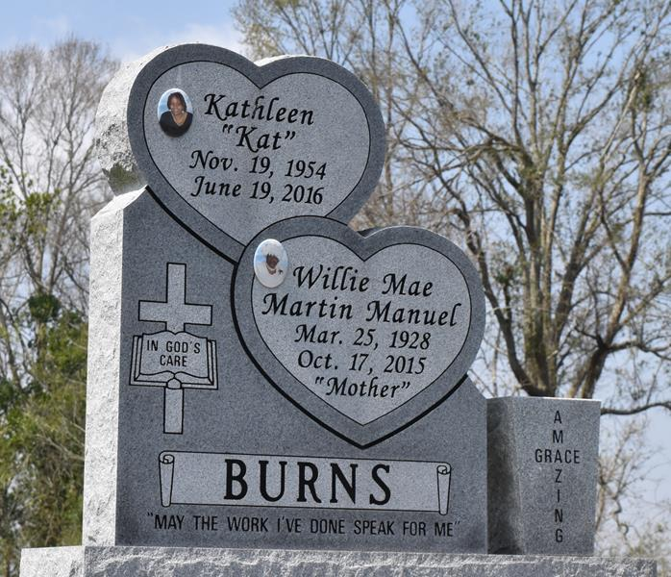

Man arrested after fatal Gramercy wreck
GRAMERCY-- A family is seeking justice after their loved one was killed by a suspected drunken driver. Latoya Washington said her aunt Kathleen Burns, 61, of Gramercy was driving to work early Sunday morning when she was hit by a car driven by Montana Hymel. "We don't feel correct justice will be served because Montana Hymel is the nephew of former St. James Parish President Dale Hymel," Washington said. "We are trying to get the case moved from St. James and let another parish handle it."
The fatal crash took place on Louisiana 3125 in Gramercy near Gem Drugs, authorities said. Lt. Jody Ordeneaux Jr. of the Gramercy Police Department said Montana was driving a pickup truck west on Louisiana 3125 just before 5:17 a.m. when the truck crossed the centerline, entering the travel lane of a Toyota heading east. "The Toyota, although maneuvering toward the shoulder, was unable to avoid the crash," Ordeneaux said. "The pickup crashed head on into the Toyota." Burns, the driver of the Toyota, was taken to St. James Parish Hospital, where she died as a result of injuries suffered in the crash. Burns was a single mother of five who worked as a nurse at St. James Parish Hospital and East Jefferson Hospital, Washington said.
Washington said the family is not satisfied with the way the case is going, because the suspect was arrested Sunday and released from custody the next day. "I think he is just going to get a slap on the wrist," she said. "I've been reaching out to different people for help. We are going to have a vigil for her June 30. We're going to try to get people to sign a petition to make sure that justice is served and make sure (the suspect) gets what he deserves. He took the life of someone who matters to a lot of people. She was a nurse. She saved lives daily."
Gramercy Police Chief Brent Dicharry said he couldn't speak on what will happen in the courtroom, adding he believes the police department did its job. "(Montana) was charged with a D.U.I, vehicular homicide and careless operation," Dicharry said. "We did everything we could do as a police department. We charged him with what we were supposed to charge him with. We had help from the State Police. There was a guy on scene that pretty much helped us to make sure we did everything right." Dicharry said, in his opinion, Montana's family connection will not play a role in the outcome of the case. Police said the suspect's blood alcohol content was .131 grams percent. The legal limit is .08 grams percent, police said. Montana was released from custody Monday after posting a $101,200 bond. Gramercy Mayor Steve Noscaka said he is not familiar with the particulars of the wreck or who was involved; however, he added he was saddened when he heard the news a Gramercy resident lost her life.

L'Observateur, La Place, Louisiana
Saturday, June 25, 2016
**

Kathleen "Kat" Burns at the age of 61 yrs. departed this earthly life on Sunday June 19, 2016 at St. James Hospital of Lutcher, La.
Daughter of the late John Sr. and Willie Mae Burns. Beloved mother of Shalanda Williams (Alton), Shatisha Burns (Donald), Shanrick Burns, Kenitra and Kendall Belvin. Sister of Barry Manuel, John Jr., Frank, Michael and Adam Burns, Joyce Smith, Linda Hayes, Debra Hills, Loretta Joseph and Carolyn Cola. Niece of Morris Martin Sr. Also survived by 9 grandchildren Jaylin, Alton Jr., Doiron, Kaitlyn, Dayton, Alonzo, Kaiden, Liam and Sydney.
Kathleen was preceded in death by her parents John W. Sr. and Willie Mae M. Burns; Brothers Alexander Manuel Jr. and Everett Burns; Sisters Sherry Robinson and Dorothy Harris, 4 uncles and 1 aunt. Also survived by a host of nieces, nephews other relatives and friends. "Kat" was a resident of Gramercy, La.
Relatives and friends of the family also Pastors, Officers and Members of First Community Antioch Baptist Church of Lutcher, La. Greater Golden Grove Baptist Church of Gramercy, La. all neighboring churches, Employees of East Jefferson General Hospital and St. James Parish Hospital are invited to attend the home going celebration on Saturday July 2,2016 at 11:00am at First Community Antioch Baptist Church, 20860 Hwy. 3125, Lutcher, La., Host Pastor Rev. Ferdinand Gaines Jr., Pastor Jarrow officiating. Interment in Antioch Cemetery. Visitation will be from 9:00am until service time at First Community Baptist Church.
Bardell's Mortuary in charge. Information:985-535-6837.

The New Orleans (LA) Advocate
Jun. 29 to Jul. 2, 2016

