Jerry Mae Clayton
June 12, 1954 – August 30, 2001

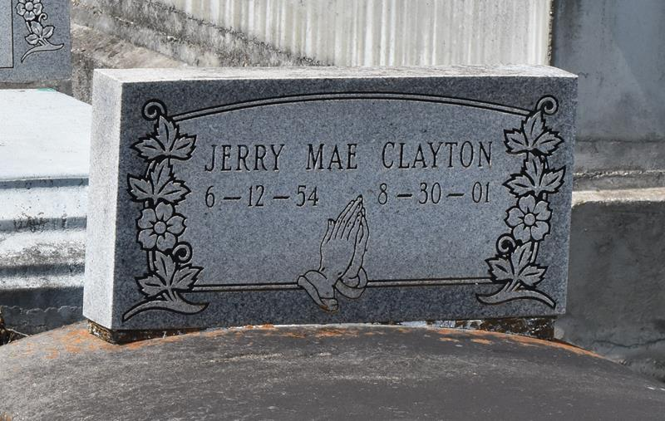

Jerry M. Clayton, a janitor for the St. James Parish school system, died Thursday at Ochsner Foundation Hospital in Jefferson. She was 47. Mrs. Clayton was born in Dorseyville and lived in Paulina for 30 years. She was a senior choir member at Evergreen Baptist Church in Paulina. Survivors include her husband, Rodney Clayton Sr.; two sons, Charlton Jackson and Rodney Clayton II; three daughters, Dannisha, Dominique and Gabrielle Clayton; and two grandchildren. A funeral will be held Wednesday at 11 a.m. at Evergreen Baptist Church, 3762 Louisiana 44. Visitation will begin at 9 a.m. Burial will be in Antioch Cemetery in Paulina. Bardell's Mortuary is in charge of arrangements.
Times-Picayune, The (New Orleans, LA) - Monday, September 3, 2001
Contributed by Jane Edson
**
PAULINA - Jerry Mae Clayton, 47, a native of Dorseyville and resident of Paulina for 30 years, died Aug. 30. She was the wife of Rodney Clayton Sr. and mother of Dannisha, Dominique, Gabrielle and Rodney Clayton Jr. and Charlton Jackson. She is survived by two grandchildren. She was a custodian for the St. James Parish school system. Services are today at 11 a.m. at Evergreen Baptist Church, Paulina, with interment at Antioch Cemetery, Paulina. Visitation starts at 9 a.m.
Unknown source; September 5, 2001

