Losten Clayton Jr.
November 10, 1926 – February 7, 2002

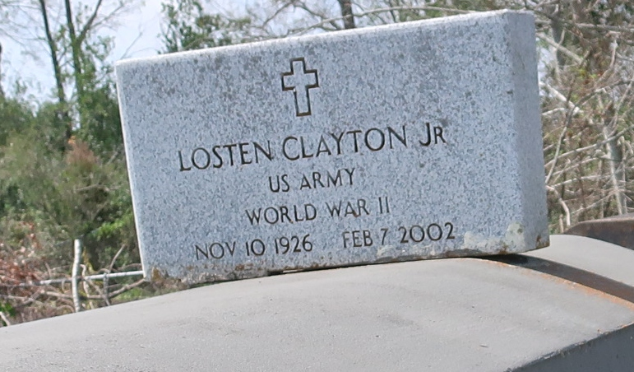

Losten "World Montana" Clayton, a retired construction worker at Boh Bros. Construction Co., died Feb. 7 of complications from cancer at his home. He was 75. Mr. Clayton was born in Mount Airy and lived in New Orleans for more than 50 years. He also had been a school crossing guard.
Survivors include his wife, Edna M. Armont Clayton, and three daughters, Shelia J. Clayton of Coppell, Texas, and Marsha C. Batiste and Lucille C. Simmons.
A wake will be held today at 7 p.m. at Mount Moriah Baptist Church, 2407 Louisa St. Visitation will begin at 5 p.m. A motorcade will leave the church Saturday at 9:30 a.m. for an 11:30 a.m. service at King Solomon Baptist Church in Lutcher. Burial will be in Antioch Cemetery in Paulina.
D.W. Rhodes Funeral Home is in charge of arrangements.
Times-Picayune, The (New Orleans, LA) - Friday, February 15, 2002
Contributed by Jane Edson

