Geneva (Kitt) Collier
May 27, 1913 – July 3, 2000

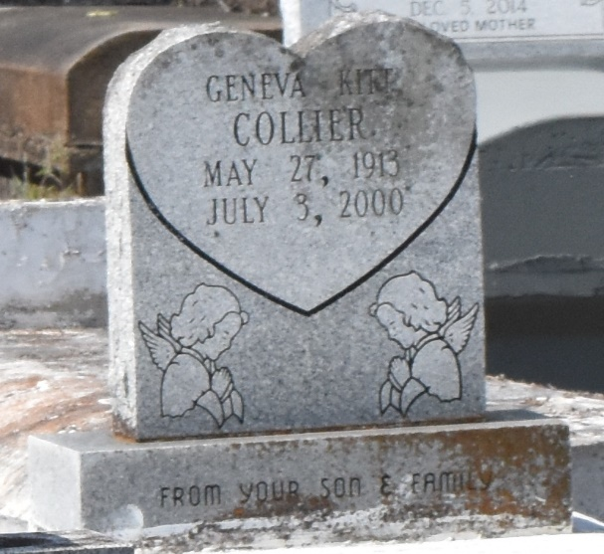

COLLIER GRAMERCY - Geneva Kitt Collier, 87, a native of Paulina and resident of Gramercy, died July 3.

She was the mother of Harold Collier. She was also the daughter of the late Victor Sr. and Carzeldia Lewis Kittand, sister of the late Ethel Collins and Victor Kitt Jr. She is also survived by two grandchildren.
Services were July 11 at Golden Grove Baptist Church, Gramercy, with interment at Antioch Cemetery, Paulina.

L'Observateur (La Place, LA)
Tuesday, July 11, 2000

