Huey P. Collier
October 13, 1935 – January 7, 2000

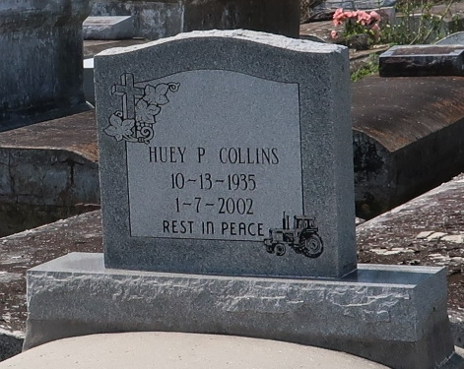

Huey P. "Goully" Collins, a retired employee of the St. James Parish school system, died Monday of leukemia at his residence. He was 66.
Mr. Collins was born in Paulina and lived in Lutcher. He was a member of First Community Antioch Baptist Church. Survivors include his wife, Melvina Johnson-Collins; four daughters, Elesha and Tarasha Collins of Lutcher, Ramona Ezidore of Gramercy and Tracey Bailey of Metairie; a son, Mark Collins of Lutcher; his father, Leroy Collins Sr.; four sisters, Audrey McField and Vera Smith of New Orleans; Carol Detiege of Avondale and Mary Collins of Paulina; two brothers, Jerry Collins of New Orleans and Terrel Collins Sr. of Gonzales; and nine grandchildren.
Visitation will be Saturday at 11 a.m. and a dismissal service will follow at noon at First Community Antioch Baptist Church at 10860 Louisiana 3125 in Lutcher. Burial will be in Antioch Cemetery. Brazier-Watson Funeral Home is in charge of arrangements.

Times-Picayune, The (New Orleans, LA)
Friday, January 11, 2002

