Philip Comb
November 9, 1904 – November 11, 1973

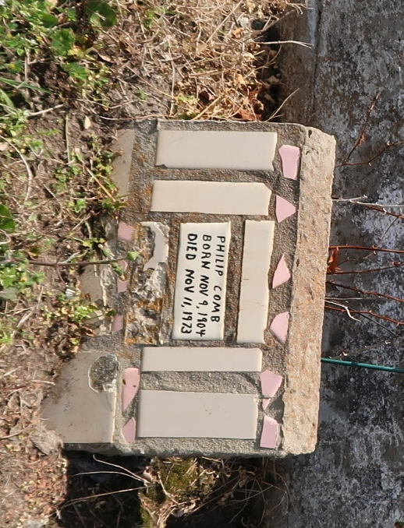

No further information found at this time.

