Mayolia (Long) Cooper
June 23, 1947 – November 11, 2014

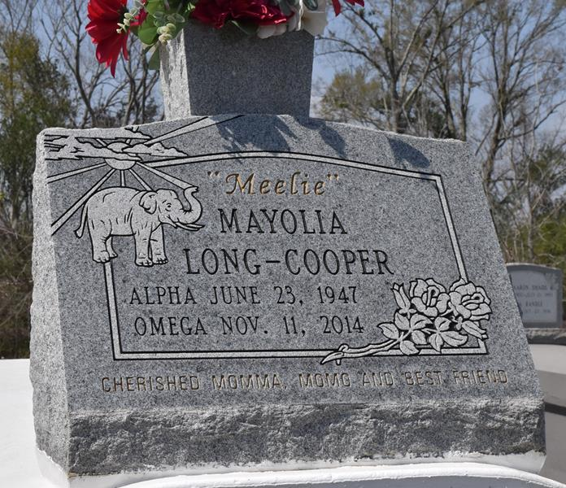

Mayolia Cooper - A native of Lutcher and a resident of Gramercy. She passed away at 1:38 P.M. on Tuesday, Nov. 11, 2014 at Ochsner Medical Center-Kenner. She was 67.
Visiting ONLY at First Community Antioch Baptist Church, Highway 3125, Lutcher, on Saturday, Nov. 22, from 9:30 a.m. until religious services at 11:00 a.m. conducted by the Rev. Ferdinand Gaines, Jr., Interment in Antioch Cemetery in Paulina.
Survived by three daughter: Lytressa Cooper, Alva Vanessa Cooper and WenQueice Coopr. A son, Adair Cooper. Six Sisters and their spouses: Dianna (Roland) Keller, Wilma Sue (George) Weber, Deborah Duperclay, Deidra (Garrett) London, Cheryl Jackson and Julliette (Donald Ray) Williams. Four brothers and their spouses: Joseph (Patricia) Long, Huey (Brenda) Long, Sr., Craig (Donna) Long and Honoray Wright. Eight grandchildren, one great granddaughter, aunts, uncles, nieces, nephews, cousins, godchildren, other relatives and friends, including Jacqueline Aubert and Mary Ann Perkins.
Preceded in death by her parents: Sampson Long, Jr., and Rosemary Wallace and her two sons, Clyde and Adam Cooper, III.
BRAZIER-WATSON FUNERAL HOME IN CHARGE OF ARRANGEMENTS.

Advocate, The (Baton Rouge, LA)
Thursday, November 20, 2014
Contributed by Jane Edson

