Bobby Davis Sr.
August 3, 1937 – December 26, 2006

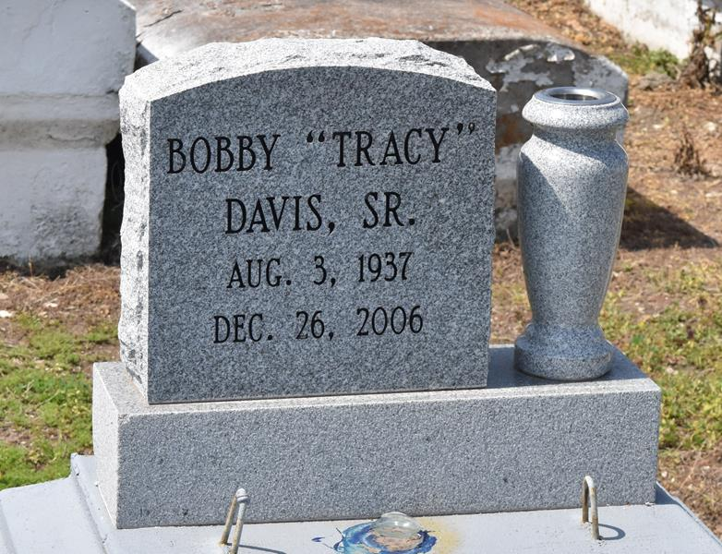

Bobby Davis, Sr. at East Jefferson Hospital, Metairie, La. at 10:27 a.m. Tuesday, December 26, 2006. Son of the late Alexander Davis, Sr. and Maude Washington Barney Davis. Father of Stephanie Johnson, Terri Williams, Donna, Rhonda, Craig Rollin and Bobby Davis, Jr. and the late Zacharias Davis. Brother of Alexander Davis, Jr., Robert Davis, Rebecca Hardy and the late Earl Davis and Lester and James Barney. Also survived by 12 grandchildren, sisters-in-law, brothers-in-law, nieces, nephews, sons and daughters-in-law, other relatives and friends, including Jacqueline Michaels. Age 69.
Visiting at King Triumph Baptist Church, Lionel Washington Street, Lutcher, La. on Tuesday, January 2, 2007 from 9:30 a.m. until religious services at 11:00 a.m. conducted by the Rev. Reginald Joseph. Interment in Antioch B.C. Cemetery, Paulina, La.
Brazier-Watson Funeral Home in charge of arrangements.

The Times-Picayune, New Orleans, Louisiana
Jan. 1, 2007

