Easter Davis
July 1901 – January 1978

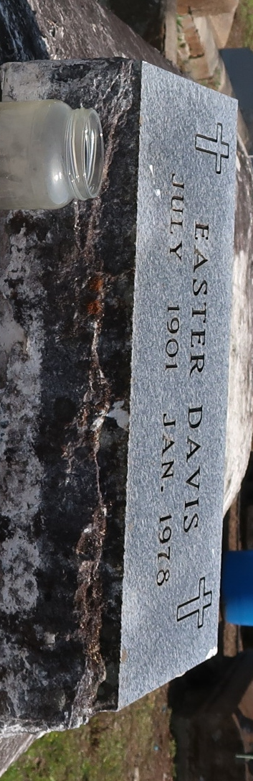

No further information found at this time.

