Frances (Paul) Dennis
January 19, 1953 – February 1, 2006

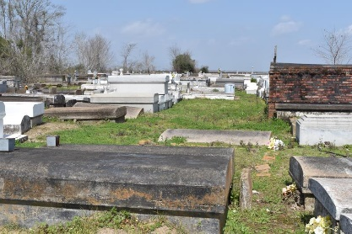

Frances Paul Dennis departed this life on Wednesday, Feb. 1, 2006, at Our Lady of the Lake Regional Medical Center at the age of 53. She was a lifelong resident of New Orleans until Hurricane Katrina forced her to evacuate to Baton Rouge.
Frances was born Jan. 19, 1953, in New Orleans to the late Frank Benjamin Paul and the late Stella Williams Paul. She was also preceded in death by her stepfather, Walter Davis; sister, Verla Jones; grandchild, Kayla Dennis; and father-in-law, Hilton Dennis Sr., who was of Cleveland, Ohio.
She is survived by her husband, Hilton Dennis Jr.; daughters, Dionne Paul, Nykeisha Dennis, Latasha Dennis-Johnson and Latoya, Janelle, Trenelle, Simone and Kamira Dennis; sons, Hilton Dennis III and Rashaad Dennis; sister, Shirley Dezara and spouse William Sr.; grandchildren, D'Kenan, Kaylon and D'John Dennis, Gabriel Peck and Sanai Dennis; mother-in-law, Melinda Williams; sisters-in-law, Debra Williams and spouse Joe, Suelynn Bowman and spouse Robert, and Karen Dennis of College Park, Ga.; brothers-in-law, Andrew Williams and spouse Uraina of Dallas and Kevin Dennis of Cleveland; son-in-law, Frank Johnson; and a host of other beloved family members and friends.
Frances Paul Dennis was a graduate of George Washington Carver Senior High School in New Orleans, Southern University at New Orleans with a bachelor's degree in elementary education and Xavier University at New Orleans with a master's degree in elementary education plus an additional 30 credit hours toward a Ph.D. She was a certified Pre-K school teacher with the Orleans Parish school system for 34 years and had taught at William J. Fisher Elementary in New Orleans prior to Hurricane Katrina.
Relatives and friends, pastors, officers and members of New Birth Missionary Baptist Church of New Orleans, Star Hill Baptist Church of Baton Rouge, employees and staff of the Orleans Parish school system (William J. Fisher and Ben Franklin elementary schools), Heritage Hyundai of New Orleans, Loyola University at New Orleans, Clark Atlanta University, New Horizon Head Start, Capitol High School, Scottlandville Middle School and Scottlandville Elementary are invited to attend the funeral service. Visitation at Star Hill Baptist Church, 1400 N. Foster Drive, Baton Rouge, on Friday, Feb. 10, from 8:30 a.m. until funeral service at 10 a.m., with the Rev. George Washington Sr. officiating. Interment in Antioch Cemetery in Paulina. Arrangements entrusted to Winnfield Funeral Home.

The Advocate, Baton Rouge, Louisiana
Feb. 8 to Feb. 9, 2006

