Audrey Mae (Beckett) Duhone
February 2, 1942 – February 18, 2009

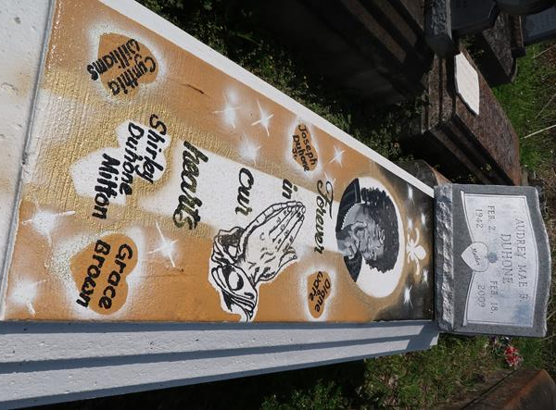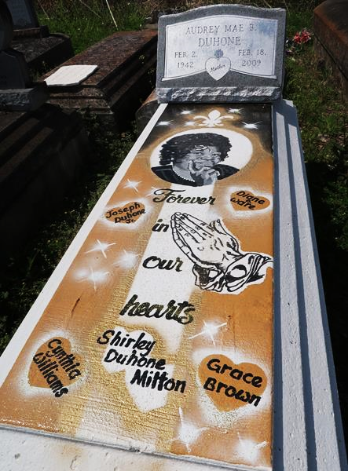

A native of Paulina and a resident of Lutcher and Gramercy, she died at her daughter’s home in Gramercy on Wednesday, Feb. 18, 2009, at 3 p.m. She was 67.
Visiting at St. Joe Baptist Church, Alexander Street, Lutcher, on Saturday, Feb. 28, from 10 a.m., conducted by Bishop Clarence Williams Sr. Interment in Antioch Cemetery, Paulina.
Survived by her children, Grace and husband Severa Joseph, Diane and husband Frank Ware, Cynthia and husband Lawrence Williams, Joseph Duhone Jr., Diazhun McKinley, Tequilla and Nancy Duhone; two sisters, Anna Lee and Betsy Beckett; a brother, Sterling Beckett; 21 grandchildren, 27 great-grandchildren and numerous nieces, nephews, aunts, uncles, cousins, other relatives and friends.
Preceded in death by her parents, Wilmer Sr. and Bernice Davis Beckett; husband, Joseph Duhone Sr.; daughter, Shirley Duhone; two sisters, Alice and Celestine Beckett; and six brothers, Sterling, August, Lawrence and Wilmer Beckett Jr., Edward Givens and Charley Davis Jr.
Arrangements by Brazier-Watson Funeral Home, Donaldsonville.

The Advocate, Baton Rouge, Louisiana
February 27, 2009

