Alexander Ezidore
May 20, 1915 – October 10, 2007

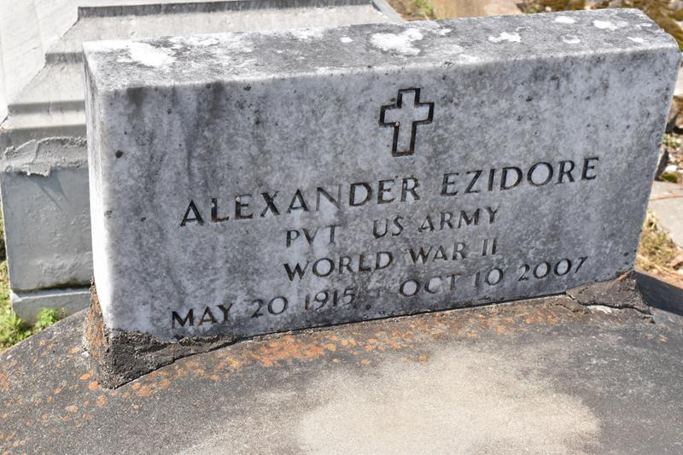

Alexander Ezidore, at his daughter's residence in Algiers, LA at 4:00 p.m., on Wednesday, October 10, 2007. Son of the late Sidney Ezidore and Annie Minor Ezidore. Father and father in law of Eunice and Robert Anthony, Larry and Joyce, Gary and Marva Fluence, Nathan Fluence and Alexander Ezidore, Jr. Brother of Artemise Williams and the late Julia Jasmin, Manuel and Pompey Ezidore, Sr. Also survived by 15 grandchildren, 12 great grandchildren, numerous neices, nephews, cousins, other relatives and friends. Age 92.
Visiting at Israelite Baptist Church, Lutcher, LA, Wednesday, October 17, 2007 from 9:30 a.m. until Religious Service at 11:00 a.m. Conducted by the Rev. Kevin Fredericks. Interment in Antioch B. C. Cemetery. Brazier-Watson Funeral Home in charge of arrangements.
The Times-Picayune, New Orleans, Louisiana
October 16, 2007

