Annette (Morris) Greenwood
August 13, 1960 – July 31, 2017

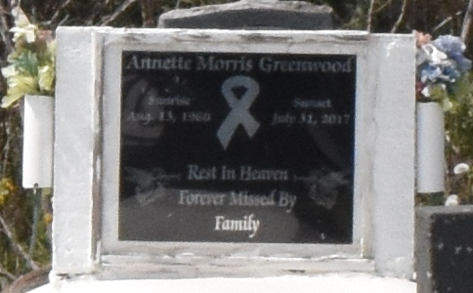

Annette Greenwood departed this life on Monday, July 31, 2017,
Daughter of Carolyn Morris and the late Cornelius Morris Sr.,
Mother of Tameka Lewis, Ashlyn and Andrew Jackson, a devoted aunt Tracey Alexander, she's also survived by 4 sisters, 3 brothers, 9 grandchildren, daughter-in-law Amanda Jackson, a host of other relatives.
Celebration service will be held on Saturday August 5, 2017 at 12:00 noon at New Zion Christian Center, 216 Main St., Gramercy, LA. Rev. Emil Dean Mitchell Officiating. Viewing at church 10am until service. Internment: Antioch cemetery Paulina, LA.
The New Orleans Advocate (Louisiana)
August 2 - 5, 2017

