Robin (Parker) Gregoire
1956 – January 25, 2016

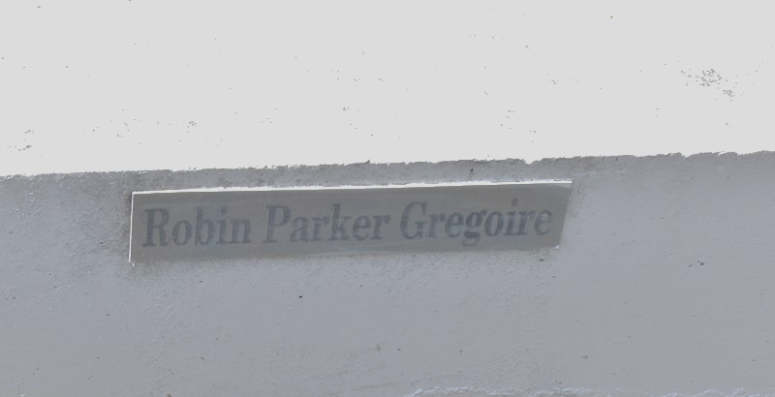

Robin "Robbie" Parker Gregoire, age 59, departed this life on Monday, January 25, 2016.
Wife of Welton Gregoire.
Mother of Latoya Parker and Ashley Johnson.
Sister of Stella Johnson, Alvin Williams, and Michael Parker.
Also survived by a host of other relatives and friends. Funeral service will be held on Wednesday, February 3, 2016, at 11:00 am at First Community Antioch Baptist Church, 10860 Hwy. 3125, Lutcher, LA 70071. Rev. Ferdinand Gaines, Pastor, Rev Herman Clayton, Officiating. Interment in Antioch Cemetery, Paulina, LA. Visitation from 10:00 am until service time.
Unknown source

