Elnora P. Hayden
April 10, 1942 – July 5, 1988

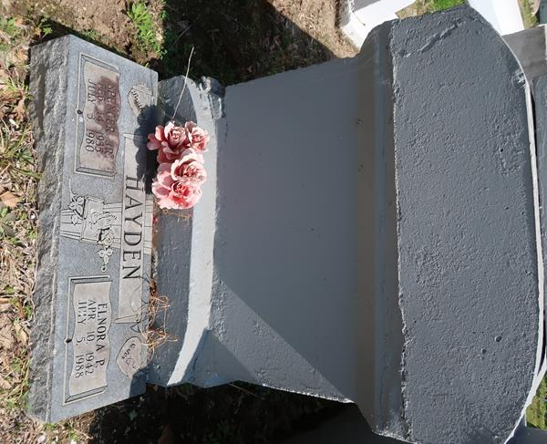

U.S., Social Security Applications and Claims Index, 1936-2007

Name Elnora Hayden
Gender Female
Race Black
Birth Date 10 Apr 1942
Birth Place Lutcher, Louisiana
Death Date Jul 1988
Father Spencer Hayden
Mother Emily G Scott
SSN xxx
Notes Jun 1960: Name listed as ELNORA HAYDEN; 12 Aug 1988: Name listed as E HAYDEN**

Elnora Hayden Parker from tree Harris Family Tree

Birth 10 Apr 1942 Lutcher, St James, Louisiana, USA
Residence 1987 New Orleans, Orleans, Louisiana, USA
Death Jul 1988 New Orleans, Orleans, Louisiana, USA
Father Spencer Sr Hayden (1910-1986)
Mother Emily G Scott Hayden (Born 1918)
53 People 5 Records 6 Sources

