Spencer Hayden, Jr.
February 14, 1955 – July 3, 1980

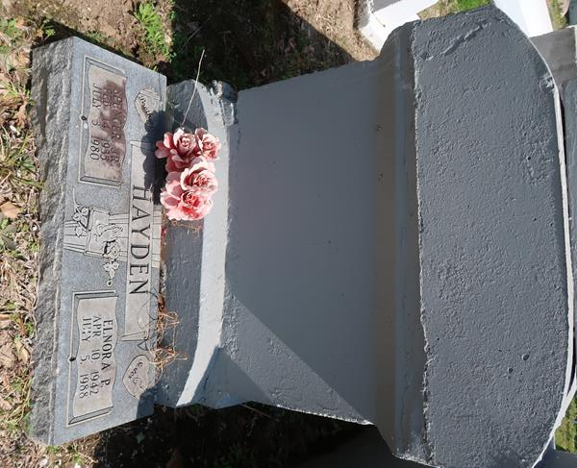

No further information found at this time

