Joseph Hayden
November 24, 1906 – October 22, 1985

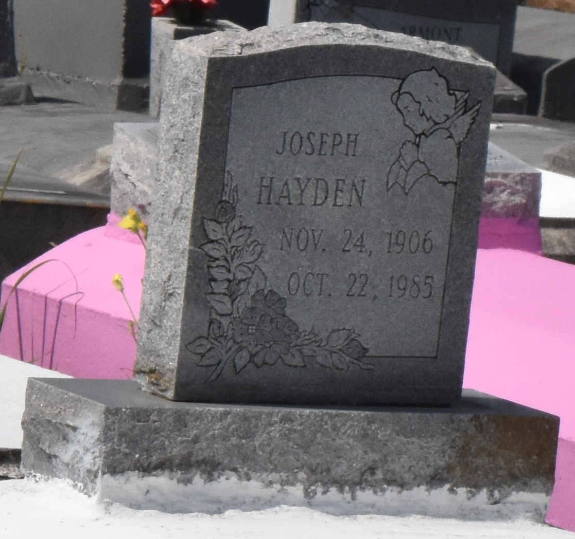

No further information found at this time

