Jimmie Holmes
October 7, 1892 – September 6, 1951

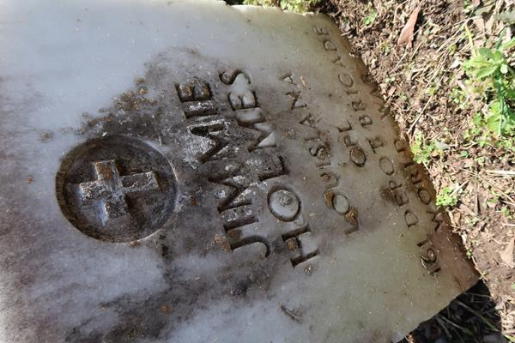

U.S., Headstone Applications for Military Veterans, 1861-1985

Name Jimmie Holmes
Birth Date 7 Oct 1892
Service Number 3331210
Unit 161st Depot Brigade
Company 25th
Enlistment Date 21 Jun 1918
Discharge Date 6 Feb 1919
Death Date 6 Sep 1951
Cemetery Antoich Cemetery
Cemetery Location Paulina, Louisiana, USA

