Dave Howard Jr.
February 16, 1925 – March 10, 2004

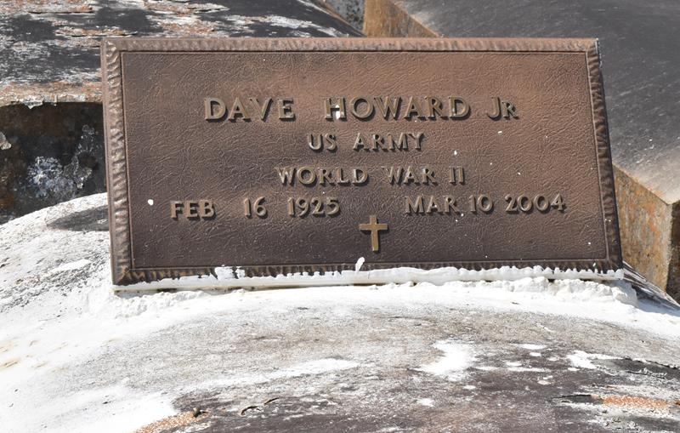

Dave Howard Jr., a factory worker, died Wednesday at Veterans Affairs Medical Center. He was 79.
Mr. Howard was born in Convent and lived in White Castle for many years. He was an Army veteran.
Survivors include a son, James Davis of San Diego; two daughters, Nettie Parquette of Garyville and Glenda H. Gaines of Reserve; 10 grandchildren; and nine great-grandchildren.
A funeral will be held Tuesday at 11 a.m. at Mount Olive Baptist Church in Paulina. Visitation will begin at 9 a.m. Burial will be in Antioch Cemetery in Paulina. D.W. Rhodes Funeral Home is in charge of arrangements.
Times-Picayune, The (New Orleans, LA)
Sunday, March 14, 2004
Contributed by Jane Edson

