Barbara Jean (Lewis) Jackson
September 18, 1952 - August 30, 2023

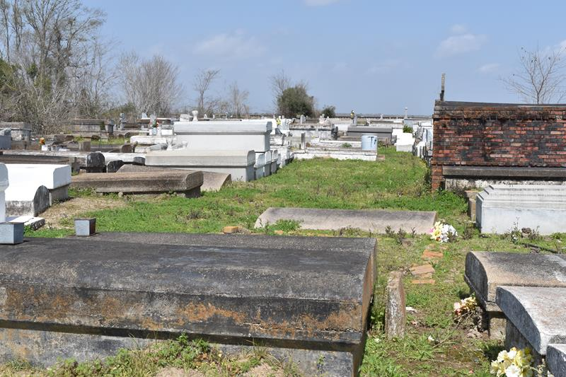
Barbara Jean Jackson affectionately known as “Bobbie” entered eternal rest on Wednesday, August 30, 2023, age 70. She was born on September 18, 1952 to the late Horace Lewis and Doretha Mollay Lewis. She was a lifelong native and resident of Lutcher, LA.
Barbara is survived by her husband Walter Jackson, Sr. She was the loving mother of DeShannon Johnson, Brittney (Dwayne, Sr.) Winfield, Romell (Janelle) Johnson, Sr. and Jaumall Joseph. She was the mother-in-law of Delacy Lewis. Barbara was the sister of Geraldine Cooper and Elaine (Samuel) Jones. She was the grandmother of 10 grandchildren, 7 great grandchildren and 2 expected grandchildren. She was the niece of LD Weary and she also had numerous nieces, nephews, other relatives and friends.
Barbara was preceded in death by her parents the late Horace and Doretha Lewis, 1 son Jermaine Lewis, Sr., and 2 grandsons Jabarie Lewis and Romell Johnson, Jr.
Relatives and friends of the family, Pastors, Officers and Members of King Solomon Baptist Church and all neighboring churches are invited to a Celebration of Life at 10:00am on Saturday, September 9, 2023 at King Solomon Baptist Church, 2385 Courseault Street, Lutcher, LA 70071. Rev. Rowdy K. Scott, Sr.-Pastor and Officiant. Visitation 8:00am until time of service at the above-named church. Antioch Baptist Cemetery, Paulina, LA.

Patrick H. Sanders Funeral Home, LaPlace, Louisiana

