Milton James Sr.
1953 – December 18, 2023

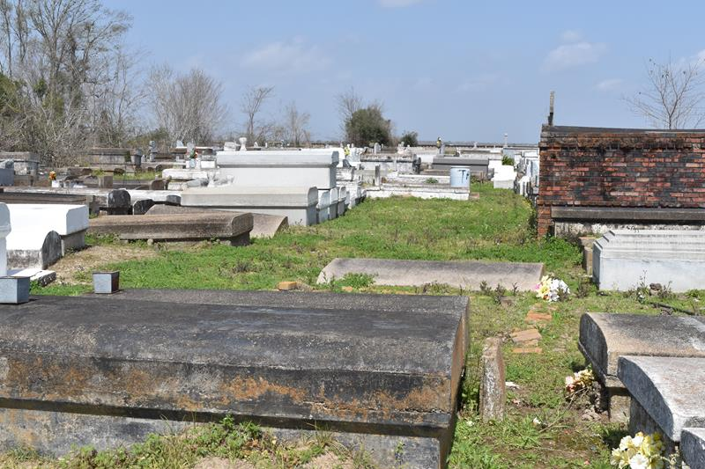

Milton “Sandman” James Sr. departed this life on December 18, 2023, at Ochsner Hospital, at the age of 70.
Husband of Patricia (Runner) James. Son of Ruth and Joseph James Sr. Father of Milton Jr. (Angela), Latricia Stirgus (Emeka), Dwan James (Alfred) and Jamond James. Brother of Rosalie Lewis (Alvin), Mary Hampton, Joseph G. James Sr. (Olga), Frederick James (Cheryl), Gloria Dumas (Sylvester), Leonard James Sr., Melinda and Wayne James.
He is survived by twelve grandchildren, four great grandchildren and a host of nieces, nephews, other relatives and friends.
Relatives and friends of the family, also employees of St. John the Baptist Parish, priest and parishioners of Our Lady of Grace are invited to attend a Funeral Mass of Christian Burial at Our Lady of Grace Catholic Church at 780 Highway 44, Reserve, LA 70084 on Saturday, January 6, 2023, at 10:00am. Viewing begins at 8am. Interment: Antioch Cemetery, Antioch Street, Paulina, LA
D. W. Rhodes Funeral Home, New Orleans, Louisiana

