Enola ‘Ma Dear’ Johnson
April 12, 1912 – October 13, 2002

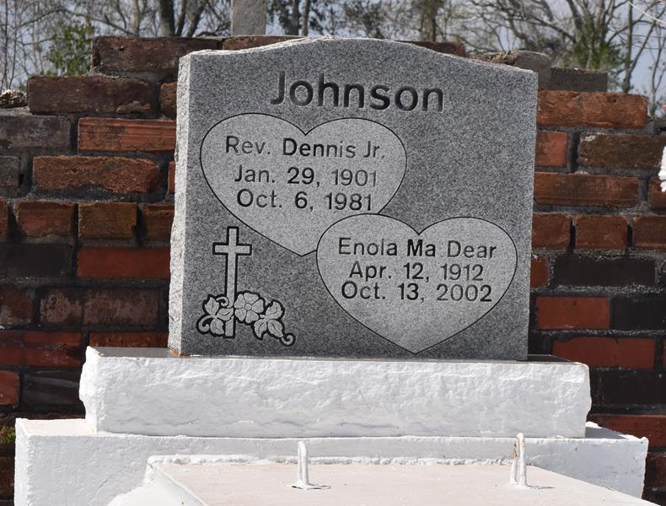

LUTCHER - Enola "Ma Dear" Johnson, 90, a native of Convent and resident of Lutcher, died Oct. 13.
She was the wife of the Rev. Dennis Johnson Jr. and mother of Faye Farlough, Hattie LaDay, Denese Washington and Dennis III, Ronald and Donald Johnson. She was the sister of Margie Jackson and Aldrich Seals. She is also survived by nine grandchildren and 13 great-grandchildren. She was a retired employee of the St. James Parish Council on Aging.
Services are today at 11 a.m. at King Solomon Baptist Church, Lutcher, with interment at Antioch Cemetery, Paulina.
L'Observateur, La Place, Louisiana
Saturday, November 2, 2002
Contributed by Jane Edson

