Warren Michael Johnson
October 23, 1955 – December 14, 2002

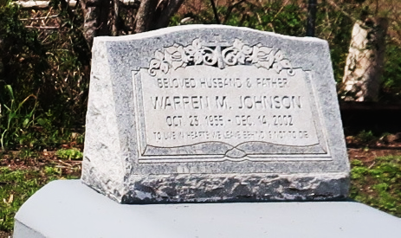

Warren Michael Johnson, a process operator for Shell/Motiva LLC Enterprises, died Dec. 14 of a heart attack at Meadowcrest Hospital in Gretna. He was 47.

Mr. Johnson was born in New Orleans and lived in LaPlace. He attended Lutcher High School and was in the Air Force for four years. Survivors include his wife, Maureen Ross Johnson; three sons, Jared Johnson, Brandon Williams and Jonathon Nelson; two daughters, Shannon Johnson and Taleisha Jacques; his mother, Ruby Johnson; seven brothers, Harry, Gerald, the Rev. Castor, Tyrone and Carl Johnson and Robert and Ricky Ross; and five sisters, Barbara Hall, Sandra Johnson, Elaine Kirklin, Joanne Andrus and Lisha Johnson.

A funeral will be held today at 10 a.m. at Mount Olive Baptist Church on Grandpoint Road in Paulina. Visitation will begin at 9 a.m. Burial will be in Antioch Cemetery in Paulina. Hobson Brown Funeral Home is in charge of arrangements.
Times-Picayune, The (New Orleans, Louisiana)
Saturday, December 21, 2002
Contributed by Jane Edson

