Estella (Johnson) Joseph
November 14, 1938 – December 25, 2001

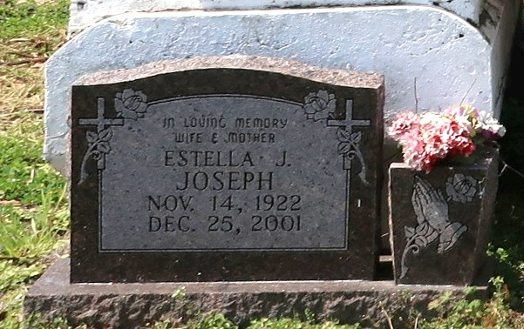

A native of Onedia and a resident of Gramercy, she died at 8:30 p.m. Tuesday, Dec. 25, 2001, as a result of an automobile accident. She was 79.
Visiting at Mount Olive Baptist Church, Paulina, from 10 a.m. Saturday until religious services at noon, conducted by the Rev. Elmo Lee. Burial in Antioch Baptist Church Cemetery, Paulina.
Survived by her husband, Samuel Joseph Sr., Gramercy; three daughters, Melba Jean Rousseau, Gramercy, and Hilda Brockett and Wanda Davis, both of Houston; five sons, Spencer and Samuel Joseph Jr., both of Gramercy, Paul Michael and Mitchell Joseph, both of Houston, and Sidney Joseph, Reserve; two brothers, Theodore Johnson, Harvey, and the Rev. John Henry Johnson, Gretna; two sisters, Albertha Marcel, Paulina, and Theresa Thompson, Convent; 26 grandchildren, eight great-grandchildren, three daughters-in-law, a son-in-law, nieces, nephews, cousins, sisters-in-law, brothers-in-law, other relatives and friends.
Preceded in death by parents, Fredrick Johnson and Dora Smith Johnson; a son, Ernest Hayes; a daughter, Stella Louise Bailey; three brothers, Arthur Sr., Alfred and Frank Johnson Sr.; and two sisters, Alma Martin and Aldonia Holloway. Brazier-Watson Funeral Home, in charge of arrangements.
Advocate, The (Baton Rouge, Louisiana)
Friday, December 28, 2001
Contributed by Jane Edson

