Jackie Joseph
November 14, 1938 – December 25, 2001

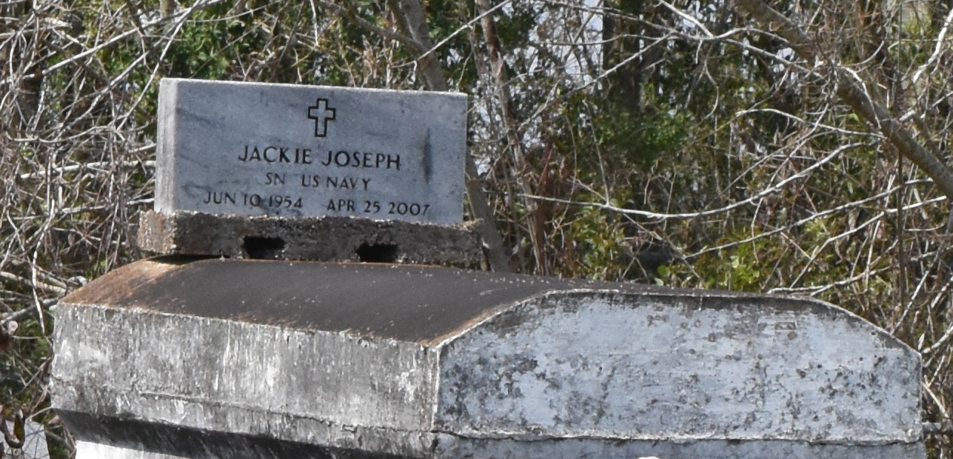

A native of Onedia (Whellam) and a resident of Houston, he died at 4:30 p.m. Wednesday, April 25, 2007, at Northwest Medical Center, Houston. He was 52.
Visiting at First Community Antioch Baptist Church, La. 3125, Lutcher, on Saturday, May 5, from 11 a.m. until religious service at 1 p.m., conducted by the Rev. Elmo Lee. Interment in Antioch Cemetery in Paulina.
He is survived by two brothers and their spouses, Ernest Joseph Jr. and wife Madeline of Gramercy and Andrew Joseph and wife Lena of Lutcher; two sisters, Stella French and husband Charles and Jacqueline Mills-Bause and husband Adam of Paulina; aunt, Edna Jones; sister-in-law, Patricia Joseph; nieces, nephews, cousins, other relatives and friends.
He was preceded in death by his parents, Ernest Joseph Sr. and Ethel Starks Joseph; brother, Joinell Joseph; sister, Dorothy Joseph; eight aunts, two uncles and a niece, Vernetta Cook.
Brazier-Watson Funeral Home, Donaldsonville, is in charge of arrangements.
The Advocate (Baton Rouge, Louisiana
May 4, 2007

