Samuel Joseph Sr.
April 5, 1924 – July 10, 2004

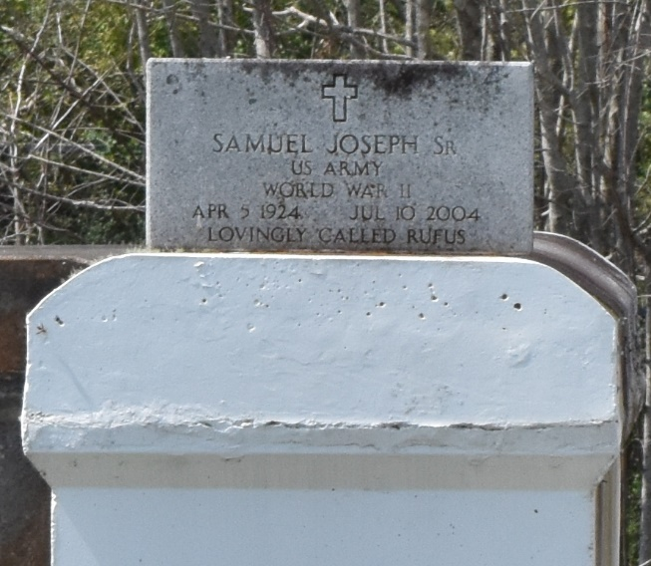

Samuel "Rufus" Joseph Sr., a laborer at Colonial Sugar Refinery, died Saturday of cancer at Canon Hospice. He was 80.

Mr. Joseph was an Army veteran and a member of Mount Olive Baptist Church.

Survivors include five sons, Samuel Joseph Jr. and Michael, Mitchell, Spencer and Sidney Joseph; three daughters, Melba J. Rousseau, Hilda J. Brochett and Wanda J. Davis; 44 grandchildren; and 23 great-grandchildren.

A funeral will be held Saturday at 1 p.m. at Mount Olive Baptist Church, 3143 Louisiana 642, Paulina. Visitation will begin at 11 a.m. Burial will be in Antioch Cemetery. Bardell's Mortuary handled arrangements.

Times-Picayune, The (New Orleans, Louisiana)
Friday, July 16, 2004
Contributed by Jane Edson

