Evelyn C. Kennoid

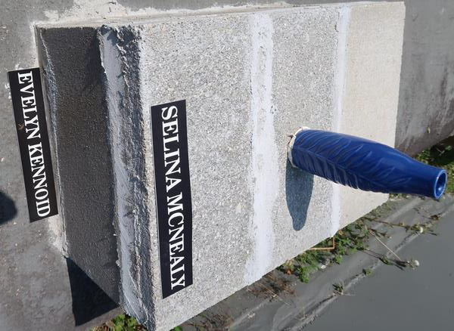

No further information found at this time.

