Viola (Martin) Kilpatrick
Abt. 1911 – April 22, 1982

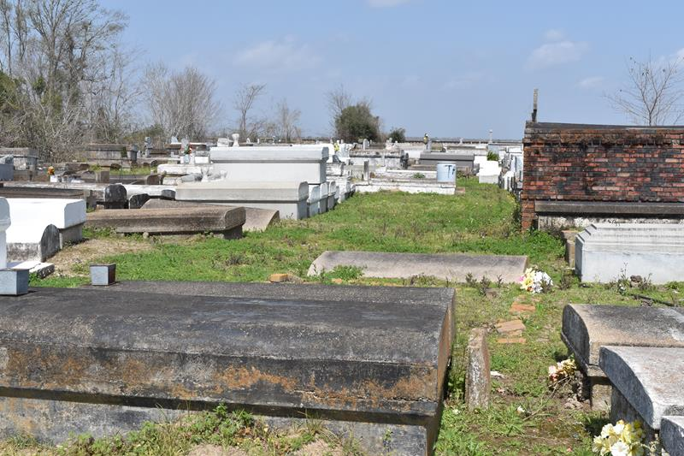

Died at 10:35 p.m. Sunday, April 25, 1982, at St. James Hospital, Lutcher. She was a native of Mt. Airy and a resident of Bat Lutcher. She was 71.
Wake services at 8 p.m. Friday at Israelite Baptist Church, Lutcher. Religious services at noon and Saturday at the church, conducted by the Rev. Louis Johnson. Burial in Antioch Cemetery, Paulina.
Survived by her husband, Ernest Kilpatrick, Lutcher, a son, and Adam Wilfred, Mt. Airy, a sister, Mrs. Willie Mae Burns, Chicago, Ill.; three brothers, Clarence Martin, Reserve, Gloss Martin, Sugar Land, Texas, and Morris Martin, Lutcher; two aunts, Mrs. Laura Burl and Mrs. Lillie Washington, both of Lutcher, an uncle, Josh Foster, Lutcher, three grandchildren, Skippy
Vilfred, Killeen, Texas, Artie Wilfred, Mt. Airy, and Mrs. Gail W. Creecy, Reserve; a daughter-in-law, Mrs. Helen Wilfred, Mt. Airy; four great-grandchildren; a number of nieces, nephews and cousins.
Preceded in death by her parents, Adam and Mary Martin; four brothers, Joe, Lawrence, Ernest and Leon Martin.
Brazier-Watson Funeral Home, Donaldsonville, in charge of arrangements.
Unknown source

