Sarah (Cambre) Kirklin
February 13, 1924 – February 22, 1998

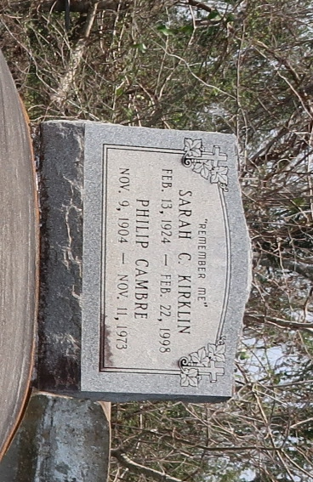

Louisiana, U.S., Newspapers.com™ Stories and Events Index, 1800's-current

Name Sarah C Kirklin
Topic Other
Residence Date 29 Jun 1962
Residence Place Lutcher, Louisiana, USA
Publication Date 29 Jun 1962
Publication Place Lutcher, Louisiana, USA
Newspaper Title The News-Examiner
**

Sarah Cambre Kirklin from tree Sara Joseph Family Tree

Birth 13 Feb 1924 Remy, St James, Louisiana, USA
Residence 1995 Paulina, St James, Louisiana, USA
Death 22 Feb 1998 Laplace, St John the Baptist, Louisiana, USA
Father Phillip Cambre (Born 1903)
Mother Cecilie Scott Rivers
Spouse Frank Will Turner
79 People 8 Records 10 Sources

