Carrie (Lockett) Lewis
January 6, 1928 – July 13, 2017

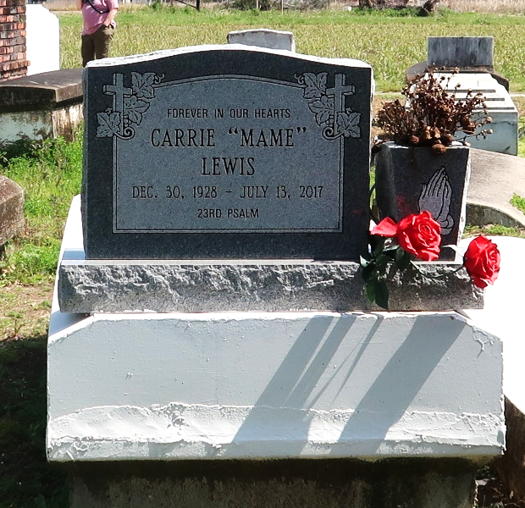

Mrs. Lewis was 89 years old and a resident of Lutcher. She is survived by her children: Robert Jones, Nathaniel Jones, Sr., Carol Johnson and husband Ronald, Sr., Linda Hartmann and husband Hermann, Lucy Bremond and husband Lon, and Rodney Jones; sisters, Joyce Giles, Jerry Dean Queen; brother William Jones; 20 grandchildren; 27 great-grandchildren; 2 great-nieces. Preceded in death by her parents, Rodney Lewis, Sr. and Cecilia Lockett Lewis; son Atwood Jones, Jr.; sister Loyce Jones; brother Rodney Lewis, Jr.

Unknown source
**
A native and resident of Lutcher. She passed away at her daughter's home in Sugarland, TX at 3:54 p.m., on Thursday, July 13, 2017. She was 89. Visiting at First Community Antioch Baptist Church, Highway 3125, Lutcher, Saturday, July 22, 2017 from 9:30 a.m. until religious services at 11:00 a.m. Rev. Ferdinand Gaines, Jr., Host Pastor, Rev. Charlie Jones, of Greater King Triumph Baptist Church, officiating. Interment in Antioch Cemetery in Paulina. Survived by her children: Robert Jones, Nathaniel Jones, Sr., Carol (Ronald, Sr.) Johnson, Linda (Hermann) Hartmann, Lucy (Jon) Bremond and Rodney Jones. Sisters: Joyce Giles, Jerry Dean Queen and Brenda (Johnny) Durio. Brother: William Jones. A daughter-in-law: Tanya Jones, 20 grandchildren, 27 great- grandchildren, 2 great-great grandchildren, numerous nieces, nephews, cousins, other relatives and friends. Preceded in death by her parents: Rodney Lewis, Sr. and Cecilia Lockett Lewis. A son, Atwood Jones, Jr. Sister, Loyce Jones. A brother: Rodney Lewis, Jr., and a daughter-in-law: Sheliah Jones. BRAZIER-WATSON FUNERAL HOME IN CHARGE OF ARRANGEMENTS.

Advocate, The (Baton Rouge, Louisiana)
Thursday, July 20, 2017
Contributed by Jane Edson

