Joseph Louis Long
July 24, 1948 – January 13, 2022

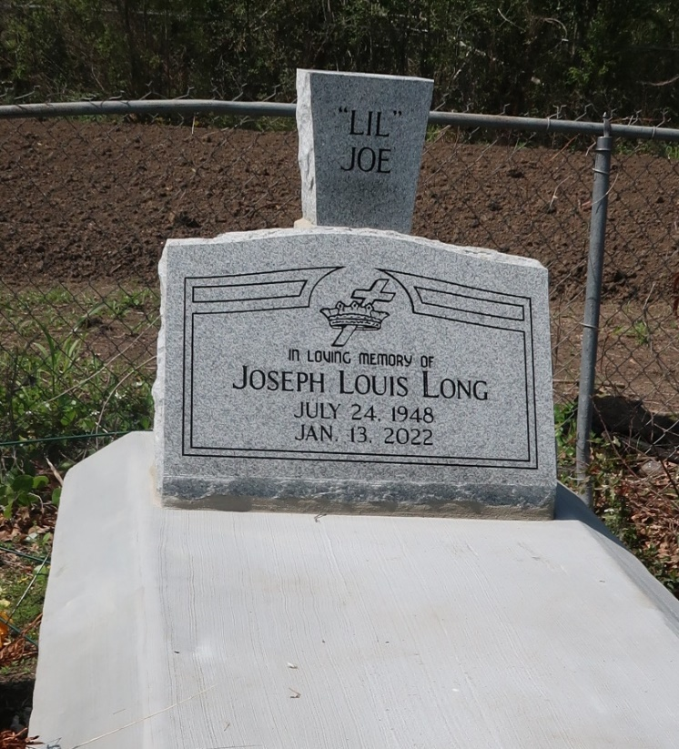

Joe transitioned into his eternal home on Thursday, January 13, 2022, at the age of 73. He was born to the late Samson Long Jr. and Rose Mary Jackson (Husband, Alfred Jackson).
Joe leaves to cherish his precious memories; his wife, Patricia Ann Long; his daughters, Nicoil Long Dewdney, Kiwauna Long Johnson, Nichelle (Demond) Miller Sr.; son, Jyvonna Gross; devoted friend, Lorraine Gross Victor; his grandchildren, Plashae Long, Jai Brown, Torre Dewdney, Dustin & Dysean Broome, Demetrius Crawford, De'marai Miller, Demond Miller Jr., De'syre Jyvona Gross, Kalien Javone Coulon; and 8 great-grandchildren. He also leaves his memories: his sisters Juliette (Donald Ray) Williams, Cheryl Jackson, Craig Long, Dianah Keller, and Debra Duplerclay, along with a host of aunts, uncles, nieces, nephews, other relatives, and friends.
Joe is preceded in death by his parents Samson Long Jr. and Rose Mary Jackson (Alfred Jackson); siblings, Mayola Cooper and Huey Long Sr.; nephews, Clyde Cooper and Huey Long Jr.
Relatives and friends are invited to attend a public viewing on Friday, January 21, 2022 beginning at 3 pm until 6 pm at Bardell's Mortuary, 3856 LA-44 Mt. Airy, Louisiana 70076. All visitors are required to wear a mask. A private Remembrance of Life service will be held on Saturday, January 22, 2022, at Bardell's Mortuary at 11 a.m. Rev. Willie Laws (Officiant) Lutcher Chapel Methodist Church, 2290 North Exchange Alley Lutcher, LA 70071. Interment: Antioch Cemetery, 3251 Antioch Lane, Paulina, LA.
Services entrusted to Bardell's Mortuary. Information: (985) 535-6837.

The Advocate, Baton Rouge, Louisiana
Jan. 20 to Jan. 21, 2022

