Albertha J. Marcell
August 7, 1912 – November 17, 2002

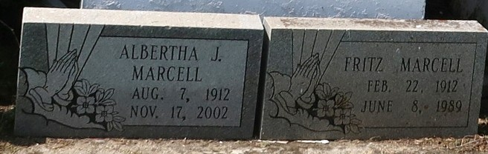

Alberta Marcell, Sunday, November 17, 2002, at 3:15 PM. Age 90 years and a native of Welham, Louisiana and a resident of Paulina, Louisiana. Mother of Margaret Russell, Alice Marcell, both of Paulina, LA. Also survived by 17 grandchildren and 26 great grandchildren.
Funeral Services will be held on Saturday, November 23, 2002 at 11:00 AM at Evergreen Baptist Church, Paulina, LA. Visitation at Evergreen Baptist Church on Saturday, November 23, 2002 from 9:00-11:00 AM. Interment Antioch Cemetery, Paulina, LA.

Times-Picayune, The (New Orleans, Louisiana)
Friday, November 22, 2002

