Clarence Martin
December 22, 1912 – December 27, 1985

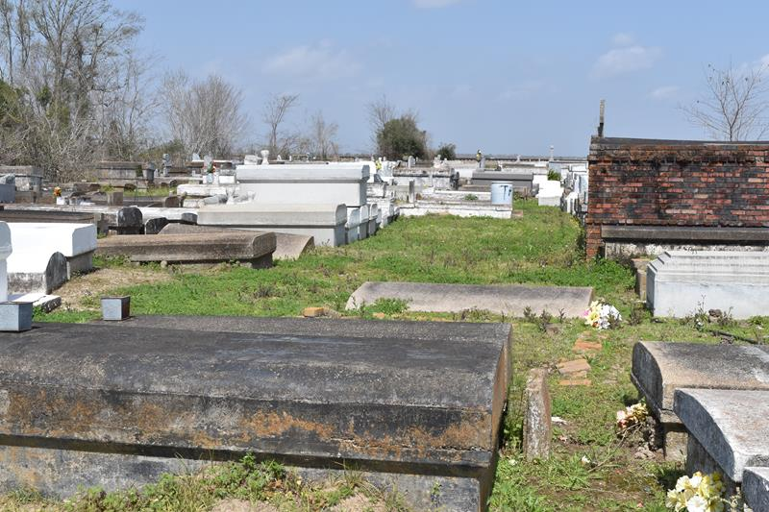

Ciarence (Diego) Martin at River Parishes Medical Hospital, LaPlace, La. Son of the late Adam and Mary Martin, beloved husband of Mrs. Dorothy Martin, father of Mary Ann, Augustine, Wayne Marin of Reserve, L. Bearice Weber of Lutcher, La., Clarence Martin Jr. of New Orleans, La., Earnest Martin of Brooklyn, New York and the late Edward and Clifton Martin, Mrs.
Willie Burns of Lutcher, La, and the late Joe, Lawrence, Earnest, Leon Martin and Viola La. A native of Mount Airy, and resident of Reserve, La. for many years. Also survived by 45 grandchildren, 18 great-grandchildren, 5 daughters-in-law, & sons-in-law, 1 brother-in-law and a host of aunts, uncles, nieces. Relatives and friends of the family also Pastor, Officers and Members of Rising Star Baptist Church… Interment Antioch Cemetery.

Unknown source
**

US World War II Draft Cards Young Men, 1940-1947

Name: Clarence Martin
Address: Mt. Airy, St. James, La.
Age: 28
Born: Dec. 22, 1912, Mt. Airy, St. John, La.
Knows address: Dorothy Martin, wife
**

Clarence MARTIN from tree MARTIN Family Tree

Birth 22 Dec 1912 Louisiana, USA
Residence 1950 St James, St James, Louisiana, USA
Death Dec 1985 Reserve, St John the Baptist, Louisiana, USA
Father Adam MARTIN (Born 1874)
Mother Mary Foster (Born 1892)
Spouse Dorothy Williams (1918-1991)
115 People 9 Records 10 Sources

