LaQuanza Kazar Mason
February 11, 1979 – April 8, 2018

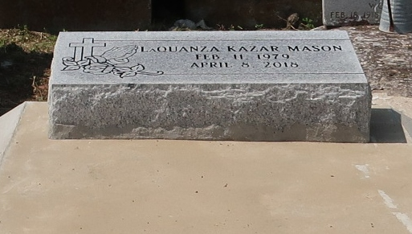

LaQuanza "Q" Kazar Mason at the age 39 yrs. departed this earthly life and entered into eternal rest on Sunday April 8,2018 at Ochsner/Kenner Regional Hospital in Kenner, La.
Beloved daughter of Elaine and Leon Mason Sr. of LaPlace, La. Loving mother of Calvin, Cardell and Jasmine. Sister of Lakeisha George (Cameron) and Leon Mason Jr. (Rosanna). Aunt of Leila, Sydney and Liam. Also survived by a host of aunts, uncles, cousins and friends. A native of Montz, La. and a resident of LaPlace, La.
LaQuanza spread her love from Baton Rouge to New Orleans, La. She was a graduate of Destrehan High School Class of 1997. She dedicated 13 yrs of service to Louisiana State Police as a dispatcher. LaQuanza is preceded in death by her grandparents Nelson and Theresa Thompson and Leroy Sr. and Carman Mason.
Pastors, Officers and Members of Providence II Baptist Church of Montz, La., Friendship Missionary Baptist Church of Kenner, La. and all neighboring churches are invited to attend the home going celebration at Providence II Baptist Church 152 Union Lane of Montz, La. on Saturday April 14, 2018 at 11:00 am where the Host Pastor is Pastor Donald Brown Sr. Pastor Reginald Holmes of Friendship Missionary Baptist Church is officiating. Burial will be in Antioch Cemetery of Paulina, La. Visitation will be at Providence II Baptist Church of Montz, La. from 9:00am until service time. Bardell's Mortuary of Mt. Airy, La. in charge. Information: 985-535-6837.
Bardell's Mortuary, Mt. Airy, Louisiana

