Selina McNealy

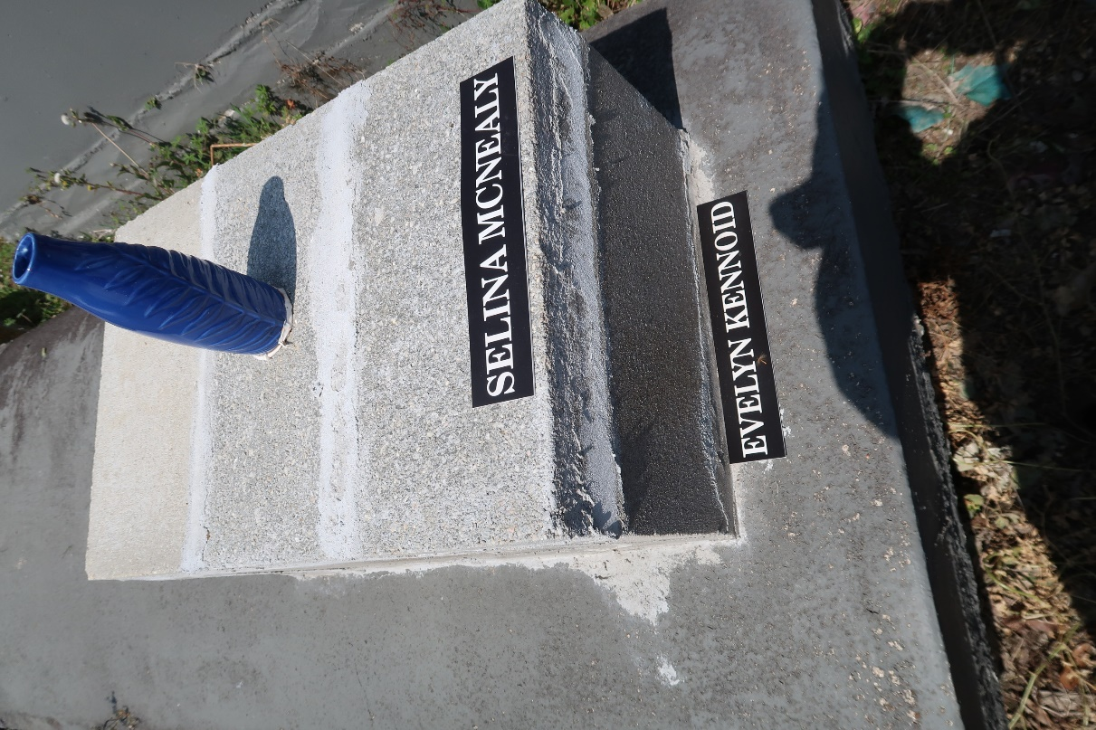

No Further information found at this time

