David Ryan Miller
Abt. 1982 – May 30, 2024

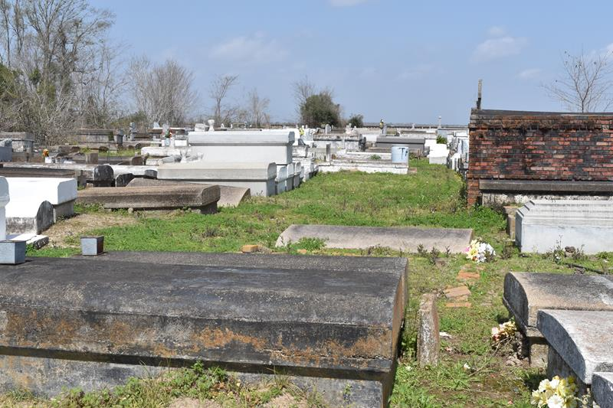

David Ryan Miller departed this life on Thursday, May 30, 2024 at the age of 42.
Son of Alberta B. Miller Skidmore and the late Edward Miller. David is also survived by stepfather Walmer Skidmore, a host of family, friends and especially is USSSA Umpire family.
Funeral service will be held on Saturday, June 15, 2024 at 10:00am at King Solomon Baptist Church 2385 N. Courseault St. Lutcher, LA. Rev. Rowdy Scott, Pastor. Antioch Cemetery. Paulina, LA.
Professional Services entrusted by Hobson Brown Funeral Home. 134 Daisy St. Garyville, LA 70051. 985-535-2516.
The Times-Picayune, New Orleans, Louisiana
Jun. 13 to Jun. 14, 2024

