Shirley M. (Duhone) Milton
November 15, 1959 – November 16, 2006

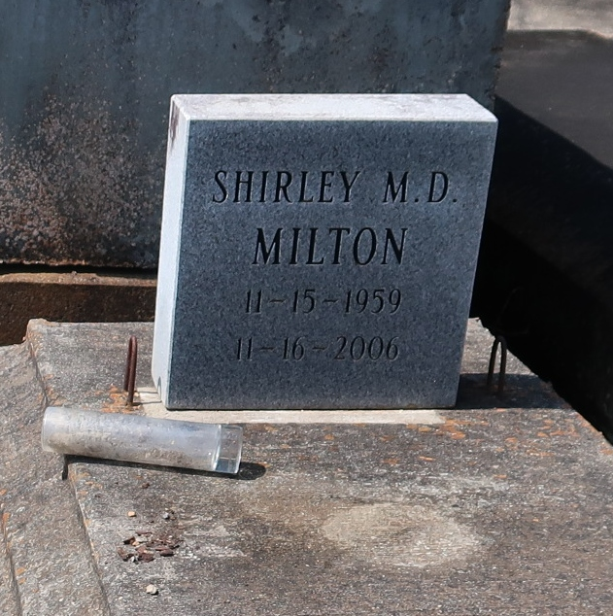

A native of Lutcher and a resident of Gramercy, she died at 10:40 p.m. Thursday, Nov. 16, 2006, at St. James Hospital in Lutcher. She was 47.
Visiting at Israelite Baptist Church, Lutcher, on Wednesday from 9:30 a.m. until religious service at 11 a.m., conducted by the Rev. Kevin Fredricks. Interment in Antioch Baptist Church Cemetery, Paulina.
She is survived by her mother, Audrey Beckett Duhone; husband, Bobbie Milton; six daughters, Kesha Russell and husband Donald, Tina, Shelita, Nancy, Ann and Angela Duhone; two stepdaughters, Danielle and Shamel Nelson; two sons, Dan and Steven Duhone; a stepson, Brandon Hubbard; three sisters and brothers-in-law, Diane and Frank Ware, Cynthia and Lawrence Williams and Grace and Severa Joseph; a brother, Joseph Duhone Jr.; 12 grandchildren and numerous nieces, nephews, cousins, other relatives and friends, including Anthony Nelson.
She was preceded in death by her father, Joseph Duhone Sr.; a daughter, Yolanda Duhone; and a sister, Nicole Kirklin. Arrangements by Brazier-Watson Funeral Home.

Advocate, The (Baton Rouge, Louisiana)
Tuesday, November 21, 2006

