Constance Vallery Mitchell
Abt. 1961 – January 23, 2003

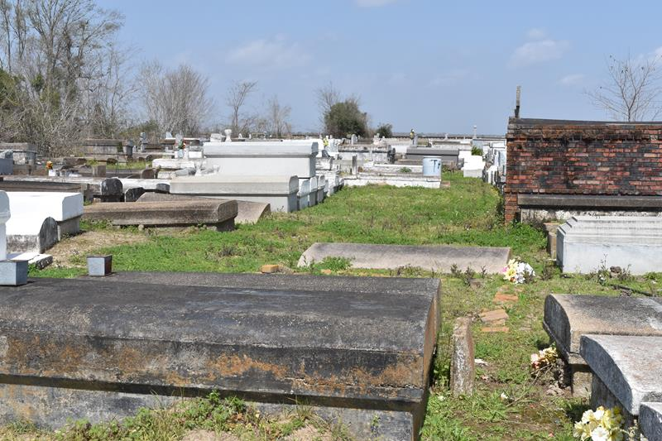
Constance Vallery Mitchell, of New Sarpy, LA, on Thursday, January 23, 2003, at Ochsner Foundation Hospital.
Daughter of Jake Scott of Lutcher, LA and Audrey Stewart of New Orleans, LA. Wife of Charles E. Mitchell. Mother of Jevon Vallery, of New Sarpy, LA. Grandmother of Devin Young. Sister of Trinette, Janice, Shelika, Cynthia, Rhea and Lance. Mother-in-law Dianna Young. Devoted Friend of Theresa Calhoun, Angela Mallacher, and Erica Nicholas. Also survived by a host of aunts, uncles, nieces, nephews, cousins and friends. A native of Convent, LA and a resident of New Sarpy, LA. Age 42 Years.
Relatives and Friends of the Family, also Pastor, Officers and Members of the Mt. Olive B.C., New Jerusalem B.C., New Sarpy, LA, and neighboring churches, and Employees of Sanders Truck Service are invited to attend the funeral services on Wednesday, January 29, 2003, at 11:00 A.M., from the Mt. Olive B.C., Paulina, LA. Rev. Elmo Lee, Officiating. Interment Antioch Cemetery, Paulina, LA. Visitation at the church after 9:00 A.M., on Wednesday. THE BALONEY FUNERAL HOME in charge of arrangements
The Times-Picayune, New Orleans, Louisiana
Jan. 28, 2003

