Darrel A. Morris Sr.
November 2, 1977 – December 5, 2000

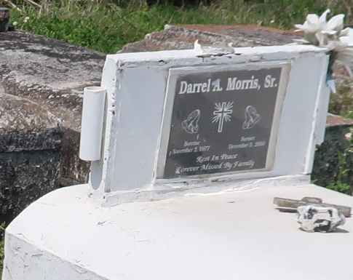

GRAMERCY - Darrel A. Morris Sr., 23, a native and resident of Lutcher, died Dec. 5.

He was the father of Jaya and Jai Lewis, DaRont'e Landry and Darrel Morris Jr. He was also the son of Darrel Johnson Sr. and Carolyn Morris and brother of Kevin Johnson, Annette Greenwood, Tammy Sylvan, Wendell Sutherland, Rose Jenkins, Grace Brooks and Catherine, Darrel Jr., Cornelius and Damon Morris.

Services are today at noon at Golden Grove Baptist Church, Gramercy, with interment at Antioch Cemetery, Paulina. Visitation starts at 11 a.m.

L'Observateur, LaPlace, Louisiana
December 9, 2000

