Leonard Morris Sr.
December 16, 1940 – November 17, 2017

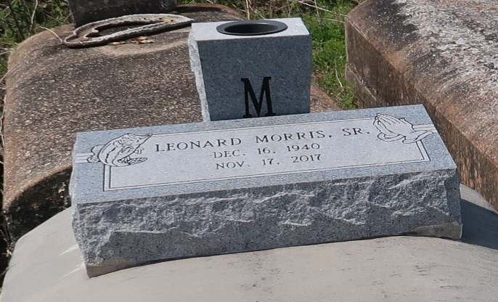

Leonard Morris - A native of Paulina and a resident of Lutcher. He passed away at St. James parish Hospital in Lutcher at 5:40 p.m., Friday, November 17, 2017. He was 76.
Visiting at New Zion Christian Center in Gramercy, Saturday, November 25, 2017 from 9:30 a.m. until religious services at 11:00 a.m., conducted by the Rev. Emil D. Mitchell. Interment in Antioch Baptist Church Cemetery in Paulina.
Survived by his wife, Maggie L. Johnson Morris. A daughter: Rhonda (Troy) Diggs. Three sons: Leonard (Sandra) Morris, Jr., and Rodney and Courtney Morris. A sister, Celestine Dunbar, 8 grandchildren, 3 great-grandchildren. Sisters-in-law: Leona Joseph, Carolyn Morris and Mary Louis Morris. Brothers-in-law: Frank Johnson and Melvin Jones; Aunt: Jersey (Allen) Henry. Uncle: Louis Russell, Sr., numerous nephews, cousins, nieces, including Brenda Scott, other relatives and friends.
Preceded in death by his parents: Louis Morris, Sr. and Rosie Bourgeois Morris. A daughter, Karen Tobias. Brothers: Cornelious, Sr., Fred and Louis Morris, Jr. Aunt, Ida Russell and Uncle, Harry Bourgeois.
BRAZIER-WATSON FUNERAL HOME IN CHARGE OF ARRANGEMENTS.

Advocate, The (Baton Rouge, Louisiana)
Wednesday, November 22, 2017
Contributed by Jane Edson

