Maggie Lee Morris
1937 – March 28, 2022

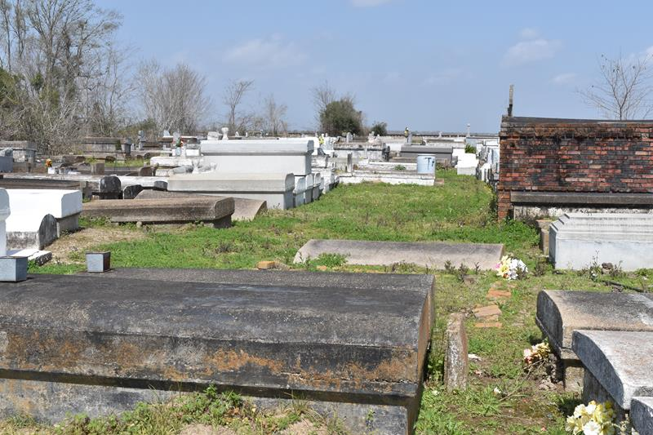

A native of Hester and a resident of Lutcher. She passed away at Chateau St. James Rehabilitation Center in Lutcher on Monday, March 28, 2022. She was 84.
Visiting at Mt. Olive B.C. in Paulina on Saturday, April 9, 2022 from 9:00 a.m. until 9:50 a.m. followed by Funeral Services at 10:00 a.m., conducted by The Rev. Oscar Nelson. Interment in Antioch B.C. Cemetery.
Survived by her sons, Rodney and Courtney Morris. Sisters, Audrey Johnson, Leona Joseph and Sandra Lee Smith. Brothers, Melvin (Barbara) Jones, Fredrick, Van and Frank Johnson, Jr. Grandchildren, Jamal, Shanika, Mario, and Terrence. Great-grandchildren, La'Anni and Shanira. Daughter-in-law, Sandra Morris, numerous nieces, nephews, cousins, other relatives and friends.
Preceded in death by her parents, Frank Johnson, Sr. and Edna Jones. Her husband, Leonard Morris, Sr. Her son, Leonard Morris, Jr. Sister, Barbara Joseph. Brother, Lawrence Johnson.
Brazier-Watson Funeral Home, Donaldsonville, Louisiana

