Orelia (Gussett) Morris
July 5, 1893 – December 10, 1977

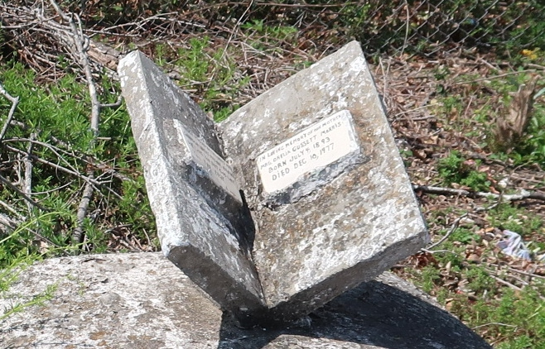

Orelia Gussett from tree Pops Side Family Tree

Birth 4 Jul 1892 Louisiana, USA
Residence 1950 St James, St James, Louisiana, USA
Death 10 Dec 1977 Lutcher, St James, Louisiana, USA
Father Nelson Gussett (Born 1864)
Mother Harriet Fowler (Born 1861)
Spouse Louis Morris I (1885-1977)
205 People 2 Records 4 Sources

