Anna Mae Nash
Abt. 1942 – January 27, 2013

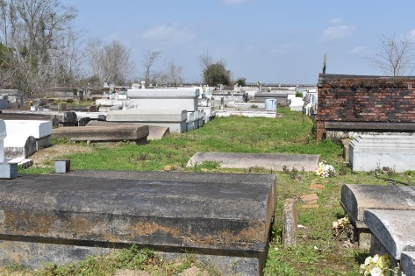

Anna Mae Nash, a retired waitress, departed this life at Ochsner Hospital on Sunday, January 27, 2013 at age 71. A native of Convent, LA and resident of Westwego, LA.
Longtime companion of Thomas Joseph Scott, Jr. Mother of Terry (Nichole) Nash, Claudette (Leonard) Austin, Marvette Harris and Herman Harris. Daughter of the late Alma Martin Nash and Albert Nash. Granddaughter of the late Dora and Freddie Johnson. Sister of the late Rose Mary Harris. Godmother of Audrey F. Williams and Tanganeal Ward. Also survived by 4 grandchildren and 1 great-grandchild.

Relatives and friends of the family and employees of La Pavillion Hotel are invited to attend the Funeral Services on Friday, February 1, 2013 at 10:00 a.m. at Davis Mortuary Service, Marrero, LA. Pastor Ricky Johnson, officiating. Visitation will begin at 8:30 a.m. until service time at the above named parlor. Interment, Antioch Cemetery, Paulina, LA.
The Times-Picayune, New Orleans, Louisiana
January 29 to January 30, 2013

