Ernest Robertson Jr.
July 7, 1937 – January 30, 2005

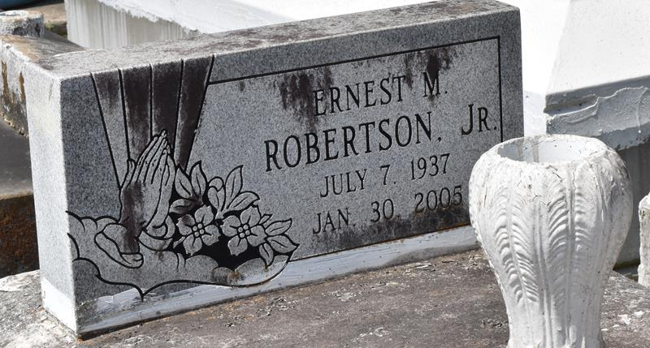

LUTCHER - Ernest Robertson Jr., 67, a resident of Paulina, died Jan. 30.

He was the husband of Idola Porter Robertson and father of Pamela Tureaud, Patricia Johnson, Paulette Duperclay, Paul, James and Tony Porter.
He was also the son of Annie Marcel Robertson, and the late Ernest Robertson Sr., and brother of Laddia Mason, Nettie Kirklin, Betty Griffin, Jeanetta Benn, Lawrence, Dave, Jackie, James, Henry and Eddie Robertson.
He is also survived by 22 grandchildren and two great-grandchildren.
Services were Feb. 5 at First Community Antioch Baptist Church, Lutcher, with interment at Antioch Baptist Church Cemetery, Paulina.

L'Observateur (La Place, Louisiana
Monday, February 14, 2005

