James Robertson
October 3, 1953 – May 5, 2008

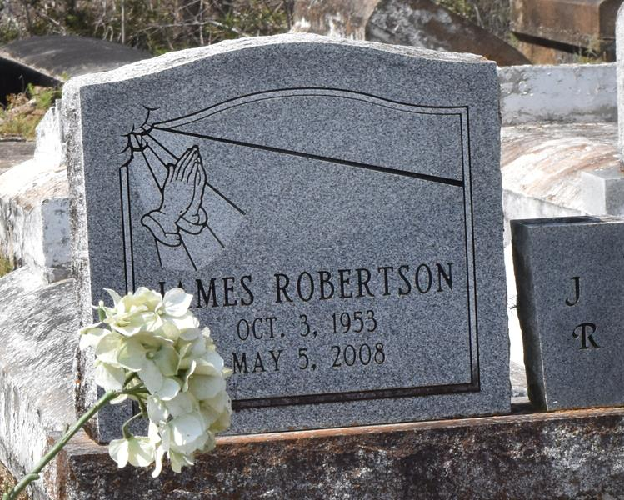

James Or Snag Robertson – A native of Lutcher and a resident of Gramercy, he died at 9:45 p.m. Monday, May 5, 2008, at River Parishes Hospital in LaPlace. He was 54.
Visiting at New Zion Full Gospel Baptist Church, Gramercy, on Saturday, May 10, from 9:30 a.m. until religious service at 11 a.m., conducted by the Rev. Emil D. Mitchell. Interment in Antioch Cemetery, Paulina.
Survived by his wife, Devaki Williams Robertson; four sons and two daughters-in-law, Jarrad and LaToya, Jamie and Ashley, and Joshua and Jonathan Robertson; four sisters, Laddie Mason, Nettie Kirklin, Betty Griffin and Jeanette Benn; three brothers, Jackie, Eddie and Lawrence Robertson Sr.; four grandchildren and a host of aunts, uncles, nieces, nephews, brothers-in-law, sisters-in-law, cousins, other relatives and friends, including Christopher Johnson, Gregory White and Kerry Robertson.
Preceded in death by his parents, Ernest Sr. and Annie B. Marcel Robertson; and three brothers, Henry, Dave and Ernest Robertson Jr. Arrangements by Brazier-Watson Funeral Home, Donaldsonville.

Advocate, The (Baton Rouge, Louisiana
Friday, May 9, 2008

