Lovina (Bourgeois) Robinson
April 2, 1932 – February 9, 2013

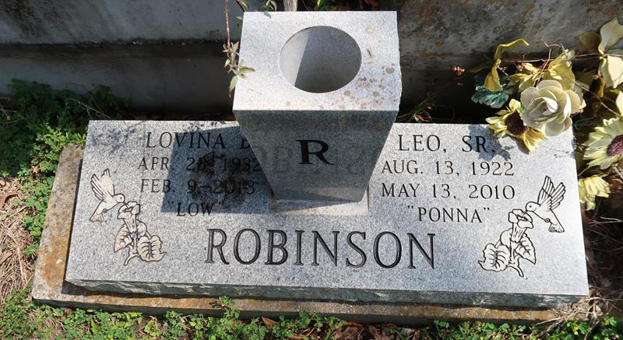

A native of Paulina and a resident of Lutcher. She died a faithful Jehovah 's Witness for over 50 years. She was 80. Survived by three daughters and their spouses; Yvonne and Raymond Joseph, Joan and Melvin Lewis, and Joycelyn and Freddie Howard. Nine sons and their spouses; Gary Scott, John, Leon, Wayne, Leo, III, Leo, Jr., and Hilda, James and Cynthia, Lloyd and Nicole, and Larry and Geraldine Robinson. Sisters; Elnora McGuffey, and Dorothy Thomas. Brothers; Manuel and Wilmer (Audrey) Bourgeois. Sisters in law, Delores Cola and Beatrice Bourgeois, 29 grandchildren, 27 great-grandchildren, nieces, nephews, cousins, other relatives, and friends. Preceded in death by her parents, Isaac Bourgeois, Sr., and Edna McCormick Bourgeois. Her husband, Leo Robinson, Sr. Two sons; Ronnie Ennis and Kenneth Robinson. Three sisters; Edna Ennis, Eunice Rixner and Rosetta Jourdan. Two brothers; Samuel and Isaac Bourgeois, Jr., and a granddaughter, Leah Robinson.
Unknown source
**

A native of Paulina and a resident of Lutcher. She died at 9:02 a.m., Saturday, Feb. 9, 2013 at St. James Parish Hospital in Lutcher. She died a faithful Jehovah's Witness for over 50 years. She was 80.
Visiting at Kingdom Hall of Jehovah's Witnesses, Admiral's Landing, Paulina, Sat., Feb. 16 from 1 p.m. until religious service at 3 p.m., conducted by Elder Amos Johnson. Interment in Antioch Cemetery, Paulina.
Survived by three daughters and their spouses, Yvonne and Raymond Joseph, Joan and Melvin Lewis, and Joycelyn and Freddie Howard; nine sons and their spouses, Gary Scott, John, Leon, Wayne, Leo, III., Leo, Jr. and Hilda, James and Cynthia, Lloyd and Nicole, and Larry and Geraldine Robinson; sisters, Elnora McGuffey and Dorothy Thomas; brothers, Manuel and Wilmer (Audrey) Bourgeois; sisters-in-law, Delores Cola and Beatrice Bourgeois; 29 grandchildren; 27 great grandchildren; and nieces, nephews, cousins, other relatives and friends. Preceded in death by her parents, Isaac Bourgeois, Sr., and Edna McCormick Bourgeois; her husband, Leo Robinson, Sr.; two sons, Ronnie Ennis and Kenneth Robinson three sisters, Edna Ennis, Eunice Rixner and Rosetta Jourdan; two brothers, Samuel and Isaac Bourgeois, Jr.; and one granddaughter, Leah Robinson.
Brazier-Watson Funeral Home in charge of arrangements.

The Advocate, Baton Rouge, Louisiana
Feb. 14 to Feb. 16, 2013

