Betty Lee (Taylor) Ross
1946 – October 13, 2015

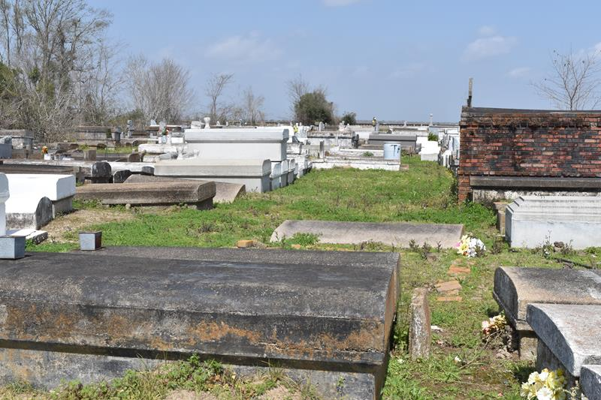

Betty Lee Taylor-Ross, at the age of 69 yrs., on Tuesday, October 13, 2015, accepted a one way ticket to eternal life at St. James Parish Hospital. She accepted her wings to spend eternity with our Lord and Savior through a peaceful transition to her heavenly home.
Beloved daughter of the late Willie Taylor and Annie Louise Smith Taylor. Beloved Mother of Robert Taylor. She shared her motherly love with the late Mickquelle Duhone of whom she reared from a very young age until his death.
She leaves to cherish her life memories to her son, Robert Taylor, two sisters Exie Payne and Mary Ann Taylor, two brothers, Willie Mack Taylor (Georgia) and Major Lee Taylor, one sister-in-law, Gertrude Taylor, 11 godchildren; Diedra Payne, Jarvis Payne, Marc Payne, Dijon Payne, Taylor Payne, Donovan Michael, Joanique T. Jeffery, Tahj Duhone, Je'Laina Carter, La'Marcus Kelson and Lasterderl Williams also a host of nieces, nephews other relatives and friends.
She was preceded in death by her parents, Willie Taylor and Annie Louise Smith Taylor, Mickquelle Duhone- whom she reared, two sisters, Bernice Kelson and Syble Taylor, four brothers, Lawrence Taylor (the late Willie Mae), Joe Frank Taylor (JoAnn), David Taylor and Samuel Taylor.
Pastors, Officers and Members of the Greater King Triumph Baptist Church of Lutcher, La and all neighboring churches are invited to attend the home going celebration on Saturday October 24, 2015, at 11:00 am at the Greater King Triumph Baptist Church 2572 Lionel Washington St. Lutcher, LA. Rev. Charles Jones officiating. Interment in Antioch Cemetery of Paulina, LA. Visitation will be from 9:00 am until service time at the above name church.
Bardell's Mortuary of Mt. Airy, La. in charge.

The Advocate, Baton Rouge, Louisiana
Oct. 22 to Oct. 24, 2015

