Lillian (Kirklin) Ross
1932 – May 16, 2000

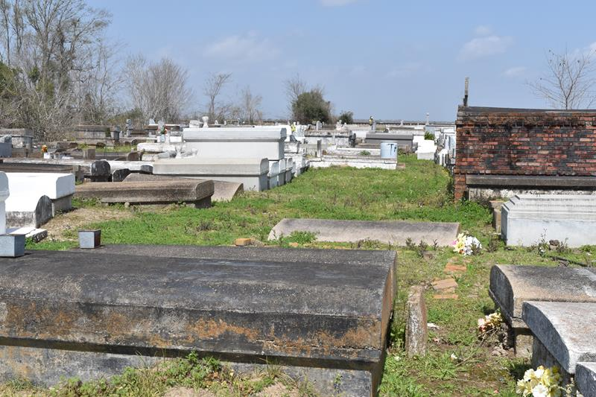

Lillian Kirklin Ross, a homemaker, died Tuesday of complications from a blood clot at Ascension Hospital in Gonzales. She was 67. Mrs. Ross was a lifelong resident of Paulina. She was a member of St. Matthew Baptist Church, where she served as a choir member and an usher.
Survivors include two sons, Robert Ross of Convent and Ricky Ross of Lutcher; six daughters, Janice Williams, Barbara Ross, Glenda Schexnayder, Leseley Smith, all of Paulina, Maureen Johnson of LaPlace and Joyce Turner of St. Croix; a brother, Robert Kirklin of Lutcher; two sisters, Emeline Washington and Ernestine Williams of Paulina; 13 grandchildren; and a great-grandchild.
A funeral will be held Saturday at 11 a.m. at St. Matthew Baptist Church at 3582 Louisiana 44 in Paulina. Burial will be in Antioch Cemetery in Paulina. Hobson-Brown Funeral Home is in charge of arrangements.
Times-Picayune, The (New Orleans, Louisiana
Friday, May 19, 2000

