Ida (Bourgeois) Russell
December 3, 1922 – October 1, 2012

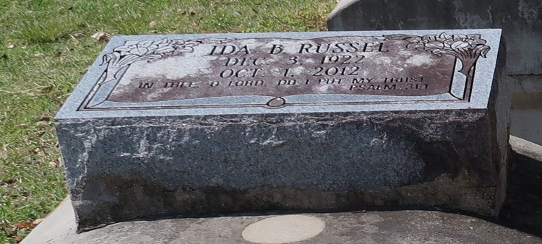

A native of Hester and a resident of Paulina. She died at her residence at 8:45 a.m., Monday, Oct. 1, 2012. She was 89.
Visiting at First Community Antioch Baptist Church, Highway 3125, Lutcher, Saturday, Oct. 6, 2012 from 9 a.m. until religious services at 10 a.m., Rev. Ferdinand Gaines, Jr., Pastor, Rev. Louis Russell, Jr., Officiating Minister. Interment in Antioch B.C. Cemetery in Paulina.
Survived by her husband, Louis Russell, Sr.; two daughters, Elaine Dyer and Dianne and husband Darryle Bolton; sons, Harold Jones, Rev. Louis, Jr. and wife Velma Russell, Jerry Jones, Vernon Russell and wife Edna, Norman and wife Terri Russell; sisters, Jersey (Allen, Sr.) Henry and Shirley Fluence; daughter-in-law, Oneata Jones; 30 grandchildren, 29 great grandchildren, 4 great-great grandchildren, nieces, nephews, cousins, sisters- and brothers-in-law, other relatives and friends.
Preceded in death by parents, Joseph Bourgeois and Elnora Price Bourgeois; son, Larry Jones; son-in-law, Harold Dyer; daughter-in-law, Judy Jones; two sisters, Velma Jones and Rosetta Dupart; brother, Harry Bourgeois; and brother-in-law, Elton Fluence.
Brazier-Watson Funeral Home in charge of arrangements.
The Advocate, Baton Rouge, Louisiana
Oct. 4 to Oct. 6, 2012

