Elijah Scott Sr.
December 29, 1936 – May 26, 2001

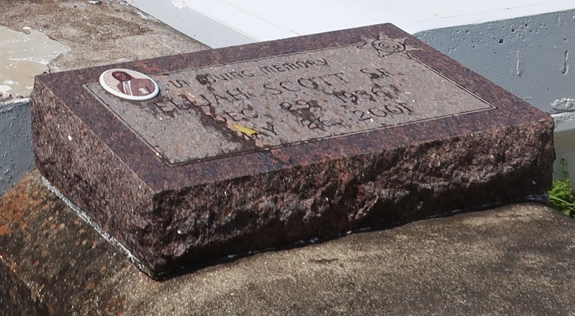

SCOTT PAULINA - Elijah Scott Sr., 64, a native and resident of Paulina, died May 26.
He was the husband of Catherine Ann Joseph Scott and father of Linda Gaines, Erica Walker, Barbara Manuel, Odeal, Eldrin, Jason, Ricky, Anthony and Elijah Scott Jr. and stepfather of Christopher and Bernard Blunt. He was also the son of the late Edward Sr. and Odeal Ward Scott and brother of Ernestine Lee, Joseph, George, Jake, Samuel and the Rev. Benjamin Scott and the late Pearly Batiste, Octavia Ezidore, Mary Sanchez and Neuman, Phillip and Alex Scott Sr. He is also survived by 28 grandchildren and 13 great-grandchildren. He was chief deputy of the St. James Parish Sheriffs Office.
Services were June 1 at Evergreen Baptist Church, Paulina, with interment at Antioch Cemetery, Paulina.

L'Observateur (La Place, Louisiana)
Saturday, June 2, 2001

